**Lesson10 Azure Active Directory**

**Notes:-**

**1-on azure portal > search for Azure Active Directory > Add User**

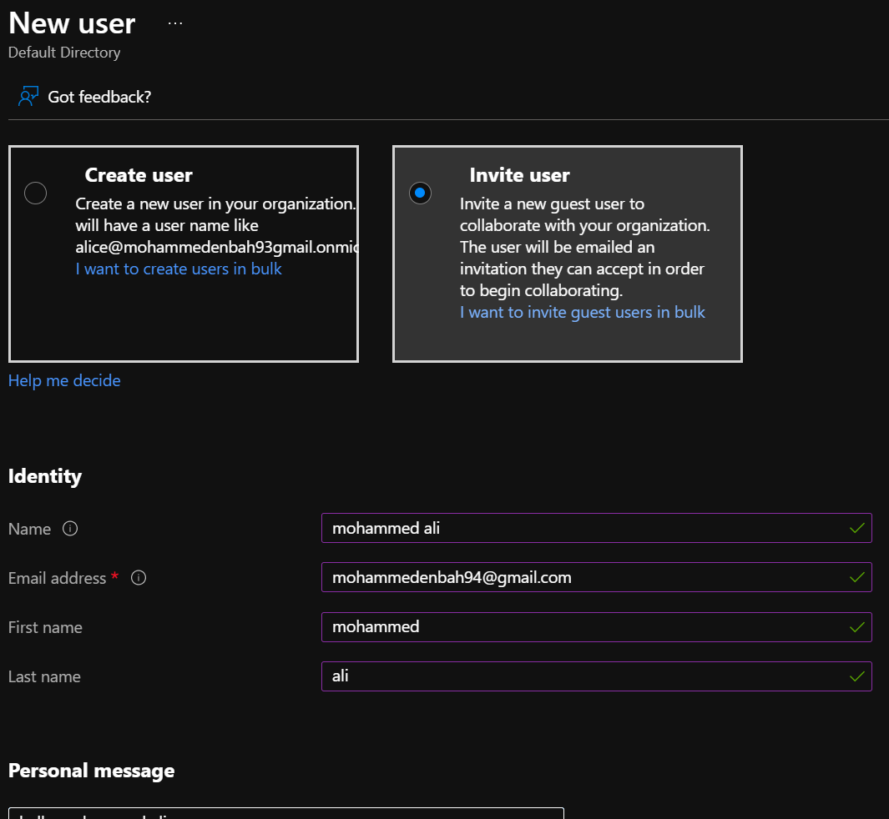

**2-it will send email to the email you want to add as new user on the azure active directory and you have to accept innovation**

**3-on azure storage account > Access Control > Add > we select roles Reader, Blob Container Read > select new user and assign**

**(It will grant access read only on blob container and on storage account in general)**

**4-try to open azure explorer and login on that new account and you will see that It provide only access to that account**